Business Template

Retail Sales Transactions Analysis
Logo / Image

Contents
1 Business Description 3
1.1 Business background 3
1.2 Problems because of poor data management 3
1.3 Benefits from implementing a Data Warehouse 3
1.4 DATASETS DESCRIPTION 3
1.5 GRAIN / DIM / FACT 4
2 Business Layer 3NF 4
3 Business Layer Dimensional Model 4
4 Logical Scheme 4
5 Data Flow 4
6 Fact Table Partitioning Strategy 4

Business Description

Business background
For this project, the focus is on retail sales across multiple store locations in Nigeria, covering both physical stores and online channels. The business collects transactional data at the point of sale, capturing details such as the products purchased, quantities, payment methods, and customer interactions. By analyzing this data, the company can gain insights into sales patterns, customer preferences, and operational efficiency. The goal is to consolidate all transactional data from different sources into a single, well-organized data warehouse that will allow for better decision-making and business planning.

Problems because of poor data managemenT
Without proper data management, it is difficult to understand the overall performance of the business. For instance, if sales data is scattered across multiple stores or systems, it becomes almost impossible to answer questions like which products are selling best, which locations are underperforming, or how online and offline sales compare. Similarly, tracking customer loyalty points, discounts, and payment trends is cumbersome when the data is not integrated. Poorly managed data also makes it difficult to identify trends over time or plan inventory efficiently, which can lead to missed opportunities, stock shortages, or excess inventory. Ultimately, this limits the company’s ability to make informed strategic decisions and remain competitive in the retail market.

Benefits from implementing a Data Warehouse
Implementing a data warehouse allows the business to integrate, organize, and analyze all transactional data from both offline and online sales. By consolidating these datasets, it becomes possible to identify trends in customer purchases, track product performance across stores, and evaluate the effectiveness of promotions and loyalty programs. The data warehouse will also support comparing sales channels, such as brick-and-mortar stores versus online platforms, helping the company understand customer behavior in different contexts. With a structured warehouse, managers will be able to answer complex questions about sales patterns, product performance, and operational efficiency, enabling them to make better decisions, optimize inventory, and improve overall business strategy.

DATASETS DESCRIPTION
The first dataset contains transactional information collected from physical stores. Each transaction records the store location, city, date and time of the purchase, cashier identifier, the number of items purchased, total amount spent, payment method, any discount applied, loyalty points earned, and a unique receipt number. This dataset represents offline transactions and is organized in a way that allows analysis of sales performance by store, city, and product quantities sold.

The second dataset is derived from the first but represents online transactions. To distinguish it from the offline dataset, all transaction IDs and receipt numbers have been modified, and the payment method is focused on digital options like mobile money, with card payments also included. This dataset maintains the same structure as the offline sales data but captures online customer behavior and ensures the datasets are different enough for integration into a data warehouse.

Together, these two datasets provide a comprehensive view of retail sales activity, allowing the business to analyze both offline and online performance, understand customer behavior across channels, and gain insights into overall sales trends, promotions, and loyalty programs. The datasets also include sufficient attributes to support the creation of dimensions for date, store location, cashier, payment method, and customer loyalty, which will be critical when designing the data warehouse.

GRAIN / DIM / FACT
The business process represented in the dataset is retail sales transactions generated through both physical stores and online sales channels. Each record captures a completed purchase made by a customer, including information about where and when the transaction occurred, how it was paid for, and the overall value of the sale.
The grain of the data is defined at the level of a single sales transaction. Each row in the dataset represents one completed transaction that took place at a specific store or online channel, on a specific date and time. This means that every record corresponds to one purchase event, regardless of the number of items included in that transaction.
At this level of detail, each transaction is fully described by its associated dimensions, including the date and time of the sale, the store and city where it occurred, the cashier who processed the transaction, the payment method used, and whether any discounts or loyalty points were applied. These dimensions together provide complete contextual information for analyzing each individual sale.
This grain was chosen because it reflects the most detailed and accurate level at which the data is captured in the source systems. Using transaction-level granularity allows the business to analyze sales performance flexibly across different dimensions such as time, location, sales channel, and payment method, while still supporting aggregation to higher levels for reporting and strategic analysis.
FACT_Transactions
Column name | Description | Data Type
Transaction_surr_id | Transaction identifier from source | int
Date_id | Fk to dim_date | int
Store_id | FK to dim_store | int
Cashier_id | Fk to dim_cashier | Int
Payment_method_id | Fk to dim_payment_method | int
Items_count | Number of items bought | Int
Total_amount_ngn | Dollar amount payed | Decimnal
Loyalty_points_earned | Loyalty points earned | Int
Discount_applied | Was the price discounted or not | Boolean
Customer_surr_id | Who we sold to | int
Avg_price | Calculated metric to analyze spending habits | decimal

Example with filled data

Sale_id | Transaction_id | Date_id | Store_id | Cashier_id | Payment_method_id
1 | POS00000000 | 1 | 1 | 1 | 1

Items_count | Total_amount_ngn | Discount_applied | Loyalty_points_earned | receipt_number | Source_system
13 | 33837.28 | FALSE | 662 | RCP0000000000 | Source 1

DIM DATE
Column name | Description | Data Type
Date_id | PK | Int
Full_date |  | date
day | Day of month | int
month | 1 through 12 | int
year |  | int
weekday |  | varchar

Example with data:
date_id | Full_date | day | month | year | weekday
1 | 2024-08-03 | 3 | 8 | 2024 | saturday

DIM_STORE
Column name | Description | Data Type
Store_id | PK | Int
Store_name |  | varchar
City_id | Which city is the store located | int
Store_src_id | Stores’ source id | varchar
Example with data:
Store_id | Store_src_id | Store_name | City_id
1 | BAL001 | Balogun Market | 4
DIM CASHIER
Column name | Description | Data Type
Cashier_id | PK | Int
Cashier_gender |  | varchar
Cashier_birthday |  | date

Example with data:
Cashier_id | Cashier_gender | Cashier_birthday
1 | Female | 1985-11-11
DIM_PAYMENT_METHOD

Column name | Description | Data Type
Payment_method_id | PK | Int
Payment_method | Name of method | varchar

Example with data:
Payment_method_id | Payment_method
1 | cash

DIM_SOURCE_SYSTEM
Column name | Description | Data Type
Source_id | PK | Int
Source_name | Name of the table | varchar
system | Which layer it came from | varchar
Source_desc |  | varchar
Example with data:
Source_id | Source_name | system | Source_desc
1 | Ce_city | BL_3NF | City table in the 3NF layer

DIM_Customer
Column name | Description | Data Type
Customer_surr_id | PK | Int
Customer_gender |  | varchar
Customer_birthday |  | date
Example with data:
Customer_surr_id | Customer_gender | Customer_birthday
1 | Male | 1985-12-12

Business Layer 3NF
SCD is a concept that describes keeping old data and keeping track of what data is old and what is new. Type 2 (SCD2) is a method where we add a new column that tells us whether this data is current or expired.
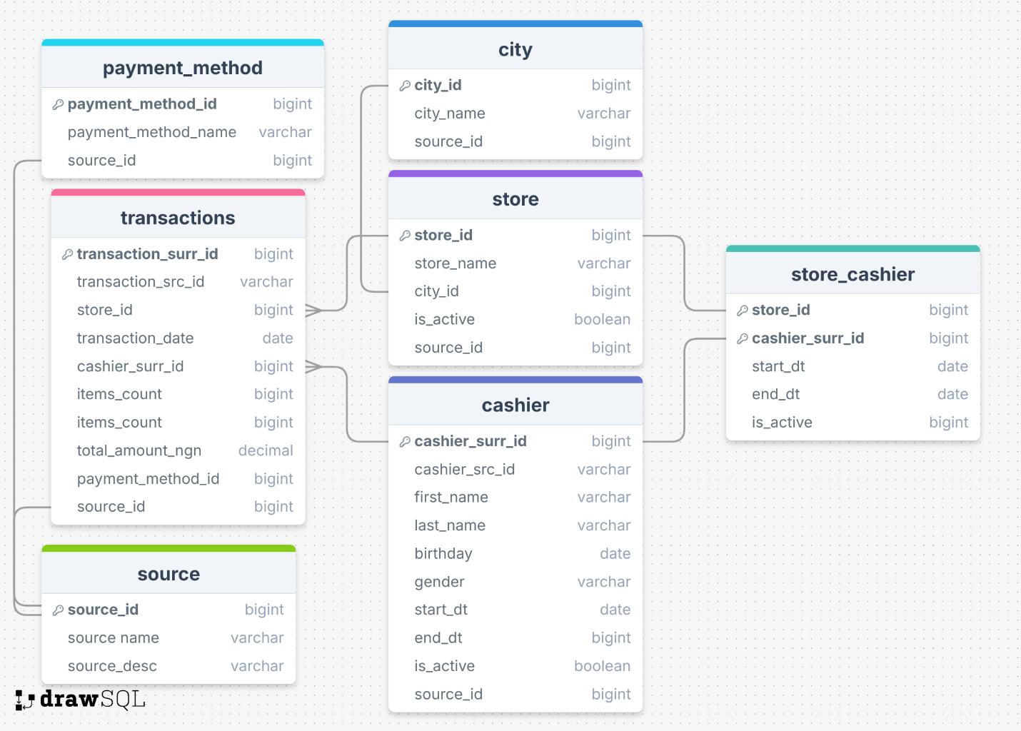
In our model each table has a source_id, to tell us whether it came from source 1 or 2.
Table ‘cashier’ has columns ‘start_date’ and ‘end_date’ to tell us when this employee was assigned and until when to a particular store. It also has a Boolean column ‘is_active’ to make filtering active/inactive assignements easier.

Business Layer Dimensional Model
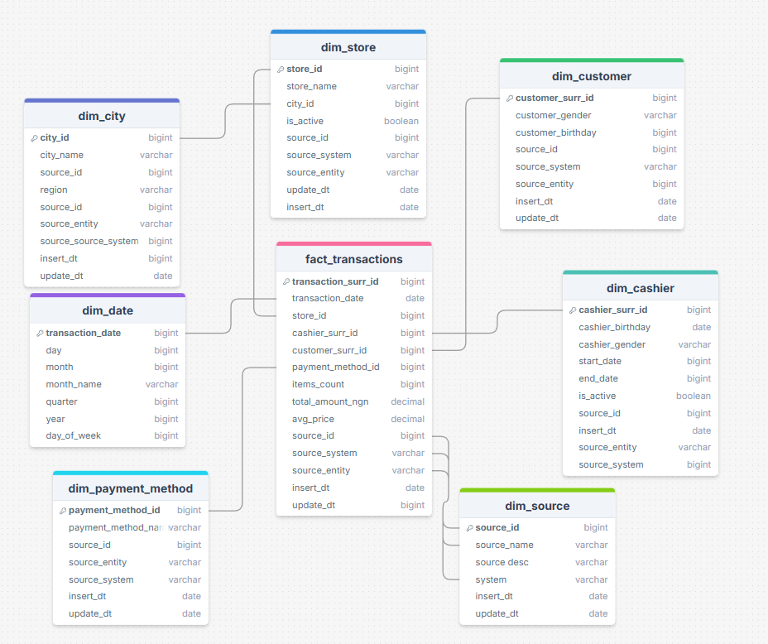
The calculated metric in ‘fact_transactions’ is the column ‘avg_price’ which will tell us how much the average product cost in this order. It will be calculated as ROUND((‘total_amount_ngn’/’items_count’),2)
This will help us in making business decisions by helping us profile customers by their spending habits.

Logical Scheme

Data Flow

Fact Table Partitioning Strategy

